AI-Augmented Backend Development Project:

TITLE: AI – WEATHER WISE API

Project Description

In a Single Paragraph
< Project Name > is an AI-Augmented backend Web Application developed using the (MongoDB, Express.js, Node.js) integrated with Artificial Intelligence capabilities such as Large Language Models (LLMs), Semantic Search, Vector Search, and Intelligent Recommendations. The system enables users to interact with data through natural language, receive AI-generated insights, perform semantic searches, upload and analyze documents, and automate decision-making processes. By combining traditional backend development with modern AI technologies, the platform delivers an intelligent, scalable, and user-friendly experience that improves productivity, accessibility, and operational efficiency.

Scenario

Weather conditions can change quickly and unexpectedly, making it difficult for people to plan travel, outdoor activities, farming, and other weather-dependent activities. Traditional weather systems mainly provide general forecasts, which may not always be sufficiently localized or timely for a user's specific location. Users may also need to check multiple sources manually to understand current weather conditions, forecasts, and possible weather risks.

Artificial Intelligence is needed because traditional systems mainly display weather data and require users to interpret the information themselves. AI Weatherwise can analyze large amounts of current and historical weather data, identify weather patterns, detect unusual conditions, and generate useful predictions. It can also provide location-based alerts and recommendations, helping users understand weather conditions more easily and make timely decisions.

AI Weatherwise brings real-time weather information and AI-based analysis together in one application. It reduces manual effort by providing weather predictions, risk alerts, and useful recommendations based on available weather data and the user's location.
.
- Describe the Proposed Solution
Explain how your < Project Name > addresses the identified problem using AI capabilities such as:
  - AI Chatbot
  - Content Generation
  - Question Answering
  - Semantic Search
  - Vector Search
  - Intelligent Recommendations
  - Document Analysis
  - AI-powered Insights

Structure:

Paragraph 1 – Problem:
Weather conditions can change quickly and unexpectedly, making it difficult for people to plan travel, outdoor activities, farming, and other weather-dependent activities. Traditional weather systems mainly provide general forecasts, which may not always be sufficiently localized or timely. Users may also need to check multiple sources manually to understand current conditions, forecasts, and possible weather risks.

Paragraph 2 – AI Solution:
AI Weatherwise uses Artificial Intelligence to analyze large amounts of current and historical weather data. It can identify weather patterns, detect unusual conditions, and provide useful predictions based on available data. The application can also provide location-based weather alerts, risk information, and personalized recommendations, reducing the need for users to manually interpret information from different sources.

Paragraph 3 – Impact:
AI Weatherwise can benefit travelers, farmers, outdoor workers, event organizers, and other users who depend on weather information. By bringing real-time weather data and AI-based analysis together in one application, it reduces manual effort and provides weather information in a simple and useful form. This helps users understand possible weather changes and make timely decisions.

System Requirements:
To ensure smooth development, deployment, and usage of the < Project Name > AI-Augmented Backend Application, certain system prerequisites must be met.

1. Software Requirements

Operating System
- Windows 10/11
- macOS
- Linux

Node.js (v18 or above)
Provides a runtime environment for frontend and backend development.

npm (v9 or above)
Package manager used for dependency installation.

Express.js
Backend framework used for API development.

MongoDB Community Server / MongoDB Atlas
NoSQL database used to store:
- User Information
- Chat History
- Documents
- Embeddings
- AI Interactions
- Application Data

MongoDB Atlas Search
Provides full-text search functionality.

MongoDB Atlas Vector Search
Enables semantic search using vector embeddings.

AI Service Provider
- OpenAI API
- Gemini API
- Claude API
- Azure OpenAI (Optional) …etc

LangChain / AI SDK
Used for orchestration of AI workflows.

Browser
- Google Chrome
- Mozilla Firefox

Postman
API Testing

Visual Studio Code
Development Environment

Git & GitHub
Version Control

2. Hardware Requirements

Processor
Intel Core i5 (8th Gen+) / AMD Ryzen 5+

RAM
Minimum 8 GB
Recommended 16 GB

Storage
Minimum 5 GB Free Space

Internet Connection
Required for AI API communication

Display
1366 × 768 or above

Project Architecture

Technical Architecture:

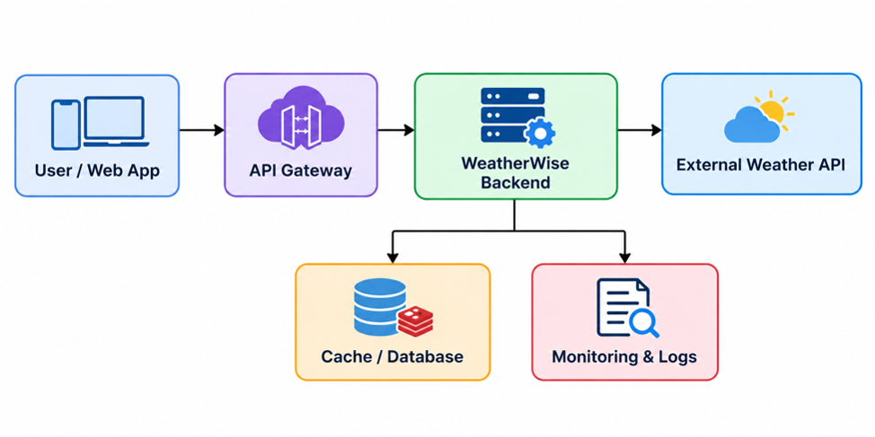

Backend Layer
- Node.js
- Express.js
- JWT Authentication
- REST APIs

Database Layer
- MongoDB
- Atlas Search
- Atlas Vector Search

AI Layer
- LLM APIs
- Embedding Models
- RAG Pipeline
- Prompt Engineering

Storage Layer
- MongoDB Collections
- File Upload Storage

Security Layer
- JWT Authentication
- Protected Routes
- Input Validation
- Role-Based Access Control

ER Diagram
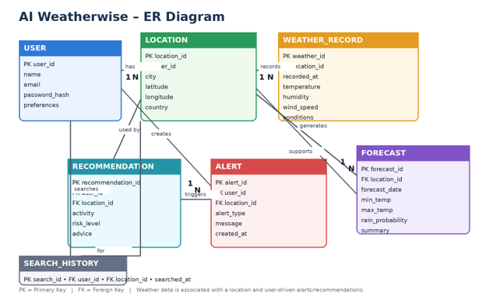

Collections

Users
- _id
- name
- email
- password
- role

Documents
- _id
- title
- content
- uploadedBy
- createdAt

Embeddings
- _id
- documentId
- vectorData

Chats
- _id
- userId
- prompt
- response
- timestamp

ActivityLogs
- _id
- userId
- activity
- createdAt

ER Diagram Explanation
Users can upload documents and interact with AI features. Uploaded documents are processed into vector embeddings and stored in MongoDB. Chat interactions and AI responses are logged for future reference and analytics. Activity logs maintain user actions across the system.

Features

Core Backend Features
- User Registration
- User Login
- JWT Authentication
- Protected Routes
- Middleware
- CRUD API
- File Upload
- Role-Based Access Control

AI Features
- AI Chat Assistant
- Semantic Search
- Vector Search
- Document Question Answering
- Text Summarization
- Content Generator
- RAG (Retrieval Augmented Generation)
- Intelligent Insights
- Natural Language Queries

Roles and Responsibilities

Admin
- Manage Users
- Manage Documents
- Monitor AI Usage
- View Analytics
- Configure System

User
- Register/Login
- Upload Documents
- Ask Questions
- Search Content
- View AI Recommendations
- Manage Personal Data

User Flow
- User Registration
- User Login
- JWT Authentication
- Dashboard Access
- Upload Documents
- Generate Embeddings
- Store Vectors in MongoDB
- User Query Submission
- Semantic Search Execution
- AI Response Generation
- Display Results
- Store Chat History

MVC Pattern
The backend follows the MVC (Model-View-Controller) architecture.

Model Layer
Responsible for:
- User Schema
- Chat Schema
- Document Schema
- Embedding Schema
- Activity Schema
Implemented using Mongoose.

Controller Layer
Responsible for:
- Authentication Logic
- AI API Integration
- Document Processing
- Embedding Generation
- Search Operations
- CRUD Operations

View Layer (Routes)
Defines REST API endpoints:

Authentication Routes
- Register
- Login
- Logout

AI Routes
- Chat
- Summarization
- Semantic Search

Document Routes
- Upload
- View
- Delete

User Routes
- Profile
- Dashboard

Advantages of MVC
- Separation of Concerns
- Better Maintainability
- Easy Scalability
- Reusable Components
- Team Collaboration
- Easier Testing

Project Setup and Configuration

Project Structure
Create Project Folder
Inside Project Folder:

Server Folder
Backend Application

Server Setup
mkdir server

cd server

npm init -y
Create:
server.js

models/
controllers/
routes/
middlewares/
config/
services/
utils/


Install Backend Packages
npm install express mongoose cors dotenv bcryptjs jsonwebtoken

npm install openai

npm install multer

npm install nodemon --save-dev


Backend Development
Include:
- Authentication APIs
- JWT Implementation
- AI Service Integration
- Vector Search APIs
- CRUD APIs
- Document Upload APIs
- Chat APIs
Note:
Proper explanation must be provided for every AI API consumed, including:
- Purpose:
- The Weather-wise API is used to collect real-time and forecast weather information from an external weather service. It provides data such as temperature, humidity, wind speed, rainfall, weather conditions, and forecasts to the AI Weatherwise application.

- Request Structure:

- The request structure defines the information sent from the Weatherwise application to the Weather API. It can include parameters such as location/city, latitude, longitude, date, and API key. These parameters tell the API which weather information is required.

- Response Structure:

- The response structure defines the weather data returned by the API. It may contain temperature, humidity, wind speed, rainfall, weather condition, forecast information, and location details. The Weatherwise application processes this response and displays useful information to the user.

- Cost Considerations:

Weather APIs may provide free and paid usage plans. The cost usually depends on the number of API requests, available weather data, forecast period, and API features. Weatherwise should use caching and efficient API requests to reduce unnecessary calls and control costs

- Security Practices:
- Weatherwise should protect API credentials and user information by using HTTPS, secure API keys, environment variables, authentication, input validation, and access controls. API keys should not be exposed in frontend code or publicly shared.

Database Development
Include:
- MongoDB Collections
- Relationships
- Atlas Search Index
- Vector Search Index
- Sample Documents
Provide screenshots and explanation.

Project Execution

Step 1: Backend
cd server

npm install


Step 2: Configure Environment Variables
Create .env
PORT=8000

MONGO_URI=mongodb://localhost:27017/ai_augmented_db

JWT_SECRET=your_secret_key

OPENAI_API_KEY=your_api_key


Step 3: Run Backend
nodemon server.js
Backend URL:
http://localhost:8000


Output with Explanation

1. Weather API Testing:
Tests the connection between Weather-wise and the external Weather API. It verifies that weather data such as temperature, humidity, wind speed, rainfall, and forecast information is received correctly.
2. AI / ML Integration:
Integrates Artificial Intelligence and Machine Learning into Weather-wise to analyse weather data, identify patterns, detect unusual conditions, and generate useful weather predictions and insights.

3. Weather Dashboard:
Displays important weather information in one place, such as current temperature, weather condition, humidity, wind speed, rainfall, and forecast details in an easy-to-understand format.

4. Location and Weather Search:
Allows users to search for weather information by entering a city, location, or other supported location details. The system retrieves the relevant weather information for the selected location.

5. Forecast Results:
Displays upcoming weather forecasts, including expected temperature, weather conditions, rainfall probability, wind information, and other available forecast details.

6. Weather Alerts and Recommendations:
Provides alerts when potentially important weather conditions are detected, such as heavy rain, storms, or extreme temperatures. AI Weatherwise can also provide recommendations to help users plan activities based on the weather conditions.

Demo Video Link
Add Demo Video URL

Source Code Drive Link
Add GitHub Repository or Drive Link

Mandatory Functionalities
- MVC Architecture
- JWT Authentication
- Semantic Search
- MongoDB Atlas Search
- MongoDB Atlas Vector Search
- Prompt Engineering
- AI API Integration
- Role-Based Access Control

